1. What is a Makefile?

A Makefile is a special file that contains instructions for compiling and linking a program. It is used by the make utility to automate the build process of software projects, especially those consisting of multiple source files. We may need to write multiple lines of commands just to simply compile a progam. This can be simplified by using Makefile for the project and build it using this makefile.

Purpose of a Makefile:

- Automation: Automates the compilation process, reducing manual effort.
- Efficiency: Compiles only the parts of the project that have changed, saving time.
- Organization: Organizes complex build processes, making it easier to manage large projects.
- Consistency: Ensures consistent builds across different environments and systems.

2. Understanding the make Utility:

make is a build automation tool/command that reads instructions from a Makefile to determine how to compile and link a program.

How make Works:

- Reads the Makefile: make reads the Makefile in the current directory.
- Determines Targets and Dependencies: It identifies the targets (files to be built) and their dependencies (files required to build the targets).
- Checks Timestamps: make checks the last modification times of targets and dependencies.
- Executes Commands: If dependencies are newer than the target (or the target doesn't exist), make executes the specified commands to update the target.
- Optimizes Builds: By only rebuilding what has changed, make optimizes the build process.

Common Make Command Examples:
make commands can be use with various options for performing various tasks related to Software development and running tasks automatically.

Following is the table of some important options with the make command.

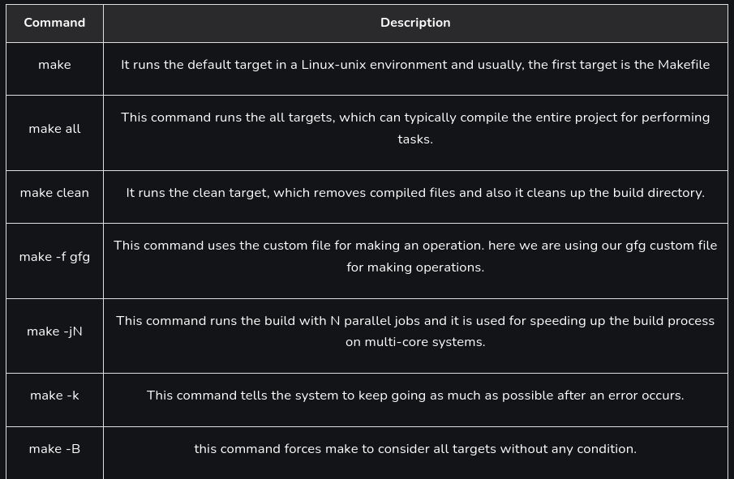
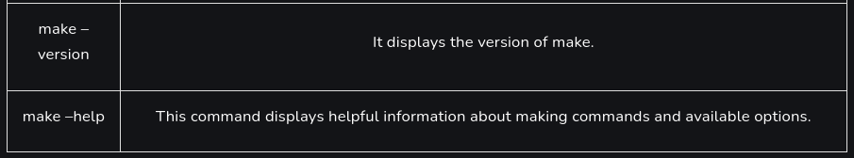

3. Basic Structure of a Makefile:

A Makefile is typically composed of rules. Each rule specifies how to produce one or more target files from a set of source files.

The general syntax of a rule is as follows:

target: dependencies
command

target: The file to be generated.
dependencies: The files required to build the target.
command: The shell command to build the target from the dependencies. This line must start with a tab character.

Makefile Variable:

We can also define variables in the makefile using the below syntax:

variableName = value

This variable can be used to refer to the given value in other parts of the makefile using the following syntax:

$variableName

